How to simulate claims for GenIns triangle

1. This is GenIns Run Off triangle (a famous paid loss example triangle)

|  |  |  |  |  |  |  |  |  |  |  |
| --- | --- | --- | --- | --- | --- | --- | --- | --- | --- | --- |
|  | 1 | 2 | 3 | 4 | 5 | 6 | 7 | 8 | 9 | 10 |
| 1 | 357848 | 1124788 | 1735330 | 2218270 | 2745596 | 3319994 | 3466336 | 3606286 | 3833515 | 3901463 |
| 2 | 352118 | 1236139 | 2170033 | 3353322 | 3799067 | 4120063 | 4647867 | 4914039 | 5339085 |  |
| 3 | 290507 | 1292306 | 2218525 | 3235179 | 3985995 | 4132918 | 4628910 | 4909315 |  |  |
| 4 | 310608 | 1418858 | 2195047 | 3757447 | 4029929 | 4381982 | 4588268 |  |  |  |
| 5 | 443160 | 1136350 | 2128333 | 2897821 | 3402672 | 3873311 |  |  |  |  |
| 6 | 396132 | 1333217 | 2180715 | 2985752 | 3691712 |  |  |  |  |  |
| 7 | 440832 | 1288463 | 2419861 | 3483130 |  |  |  |  |  |  |
| 8 | 359480 | 1421128 | 2864498 |  |  |  |  |  |  |  |
| 9 | 376686 | 1363294 |  |  |  |  |  |  |  |  |
| 10 | 344014 |  |  |  |  |  |  |  |  |  |

1. We are interested to simulate synthetic claims to generate the triangle as close as possible. So, let us use ReservePrism to do the test.
   1. Here is the incremental format

|  |  |  |  |  |  |  |  |  |  |  |
| --- | --- | --- | --- | --- | --- | --- | --- | --- | --- | --- |
|  | 1 | 2 | 3 | 4 | 5 | 6 | 7 | 8 | 9 | 10 |
| 1 | 357848 | 766940 | 610542 | 482940 | 527326 | 574398 | 146342 | 139950 | 227229 | 67948 |
| 2 | 352118 | 884021 | 933894 | 1183289 | 445745 | 320996 | 527804 | 266172 | 425046 |  |
| 3 | 290507 | 1001799 | 926219 | 1016654 | 750816 | 146923 | 495992 | 280405 |  |  |
| 4 | 310608 | 1108250 | 776189 | 1562400 | 272482 | 352053 | 206286 |  |  |  |
| 5 | 443160 | 693190 | 991983 | 769488 | 504851 | 470639 |  |  |  |  |
| 6 | 396132 | 937085 | 847498 | 805037 | 705960 |  |  |  |  |  |
| 7 | 440832 | 847631 | 1131398 | 1063269 |  |  |  |  |  |  |
| 8 | 359480 | 1061648 | 1443370 |  |  |  |  |  |  |  |
| 9 | 376686 | 986608 |  |  |  |  |  |  |  |  |
| 10 | 344014 |  |  |  |  |  |  |  |  |  |

* 1. Since we don’t know any counts information, we can have various results. But let us assume we have Annual Frequency of 1200.
  2. We are pretty sure this is a very long tail business, since the accident year 1 claims are still developing.
  3. I will ignore limit and deductible calculation (so I set deductible to 0, and limit very high)
  4. I will assume single payment of each claim (which is very unlikely in real life for this long tail business, but let me start with it)
  5. I am interested to see the rectangle from other methods first, so I tried Mack method. I can see the ultimate losses are very persistent, except the accident year 1.

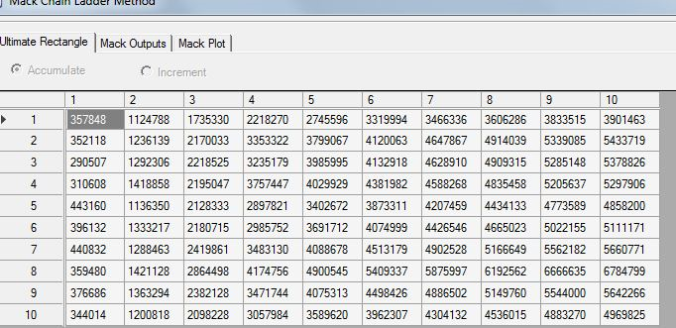

So I will take a wild guess of severity with a lognormal distribution, with mean around:

5,000,000/1,200=4,200. So, I did tons of trials here to set the distribution, with mean around 4200 and some stv. And I chose the following distribution finally:

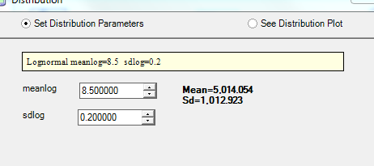

* 1. Now let us guess Report Lag and Payment Lag. **This is the hard and tricky part,** **to spread the claims to be paid in development years.** And after tons of trials, different distributions, I keep the following settings:

Report Lag: mean and std all 200 days, Exponential distribution (could try Weibull also).

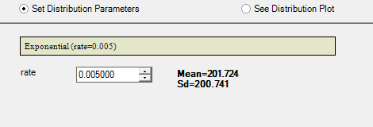

Payment Lag: Mean and std at about 1200 days, Exponential distribution (could try Weibull distribution also)

